PHASE 1
Project Specification Document

GeoInfo Access
Jason Chalom 12S

§
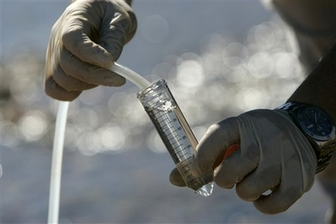
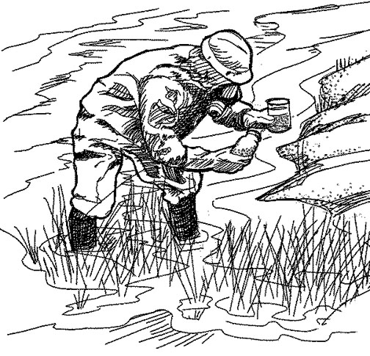

Developed by Jason Max Chalom

Signoffs
Phase | Teacher | Date | Signature
1) Project Specification | Mrs. de Wet

1. Summary
A software solution is needed which store raw data collected from can water, climatological and ecological tests done in a specific area and then process the data
The department of Environmental Affairs and Forestry, and the geography department at King David High School Linksfield require a computer solution to store ecological data and other geographical data collected in the field. Currently, The Department of Environmental Affairs uses an excel spreadsheet to store data collected from many different sources, and King David’s geography department stores their data on hardcopy. The Department of Environmental Affairs only stores raw data in the excel spreadsheet and does not process it since the people who claim the data from them are expected to process it themselves. The Department of Environmental Affairs also do not store ecological data but rather just water test sample data. Both parties require a software solution which is able to input water test data and other geological data as well as simple processing of the data such as measurement conversions. In this project I am going to make a Java program with an Access database and the ability to save to text files for storage.

2. Features of the program

2.1. Specifications of Program Functions
The program will be able to do the following:
Program Functions | Justification
Have a user-friendly interface | The program must be easy to use so that the business does not have to spend a lot of money training its staff to use the program and the staff can quickly and easily use the program since its function is to save time not increase the amount of time needed to access this data.
Have Access Database connectivity | The program must be able to store data into a normalized database which is able to give order to the data being stored so that it is easily found and processed.
The program must be able to exit once it has been opened. | If the program cannot exit then it will not be user friendly and may cause problems for other programs on the host computer.
The program must be able to display error messages concerning opening the database and closing the database in the console and the error messages must be meaningful. If there are no errors then the program must display a message that everything is functioning in the database. | This also concerns user-friendliness because if there is an error which occurs in the program without a proper error message, the user will not know what is wrong with the program and will not be able to even try to diagnose and fix the problem or tell the creator what the problem is. There should be some feedback to the user even if the program is working so that they know what is going on with the program if it is taking time to function.
The program must have an about box. | It is important for the program to have an about box so that it can be identified who wrote the program and if there is a problem occurring from the program the creator can be contacted and can fix the problem.
The program must be able to use queries to display the data from the database. | The program must be able to sort the data from the database into relevant data that can be used by the business effectively and quickly.
The program must be able to input and output to text files. | The settings for the program have to be stored into a text file and also ecological survey data collected in the field is usually a lot of text which is cumbersome to store in a database. The text file will have to have some formal layout such as heading so that the application can identify what data is being inputted.
The program must be able to handle multiple data types such as text, real numbers, integers and Booleans. It must also have the data for each test site grouped together somehow ie. arrays or separate instances of individual classes ect.... | Geological data comes in many different forms, from numbers to text and even Booleans. Such as, if there is eutrophication in water at the test site. The data for each test site should be kept together so that conclusions can be made holistically on the entire data set for each specific testing site

2.2. Specifications of User Interface
The user-interface will have the following:
- Password Screen
  - Will have an option to input username and password
  - Will have a button to continue to the main screen which will open when this password screen is closed.
- Screen 1
  - File drop-down menu
    - The file drop down menu will offer a quit option
    - An input option to add data to the system
      - Open the input window
    - An open sub-menu
      - Open Txt ➔Open a text file for import
  - Edit drop-down menu
    - Will have a copy option
    - Will have a paste option
    - Will have a settings menu option which will open the settings window
  - Help drop-down menu
    - Will have a help menu option ➔ open the help window
    - Will have about menu option ➔ open the about dialogue window
  - A panel where objects such as the text pane can be placed
  - Text pane used for output of data
  - Buttons for choosing the medium of output (dialogue or text file) and another button to select what type of data to output
  - An input button which will open up a window with a form in order to input specific types of the data or many types of the data.
- About Box
  - A window with contact details of the programmer for support. Such as an email address.
- Help Option to Display in Adobe Reader
  - Will display the PDF help file
- Input Dialogue
  - Will be an form to input data
  - Will have different sections for each type of data
  - Each section will have textboxes to input different types of data. The size and layout of textboxes depends on the type of data designated for each text box.
  - There will be two buttons at the bottom, one cancel to cancel the input and an accept one to accept the input.
- Settings dialogue window
  - Has text box and button to create a new user and password
  - Button ➔ Can reset setting by renewing (ie deleting and recreating) the settings file (ini)

2.3. Specifications of Help
The following help features will be available:
- Help dropdown menu ➔help menu option (on the main window) is used to open up the help window. F1 can also be used to open up the help PDF file
- When help has been select (either F1 or from the dropdown menu) it will open up a PDF help file.
- This file will have screen shots and a step by step tutorial about each screen and how to achieve common tasks within the program such as adding or displaying data.
- It will have a definite structure within the help file. There will be a cover sheet, table of contents and then the actual help contents.

2.4. Specifications of Data Storage
The following data storage will be available:
- Other settings data for the application will also be saved into a text file. There will be identifiers of different sites so that fields in the database can be linked to the text files and visa versa.
- The name and location of the test sites stored in the database in its own table called tblSite
  - Fields:
  - The auto generated conclusions for each test site
  - The SiteID
  - SiteName
  - SiteLocation
- The settings data will be stored in its own text file called settings.ini
  - The save location for the program
  - Where the last database and text file is located
  - Administrator/default Username and password
- The username and password data which will be encoded from the application will be stored in a table tblUser
  - The user name
  - The user password
  - The UserID
- The ecological data will have its own table in the database called tblEcology
  - SiteID
  - UserID
  - The ecological data For example:
    - Phosphates
    - Sulphates
    - Nitrates
    - Plant amounts
    - Animal amounts
  - Other ecological data such as the field survey which is text and observations is stored in a text file and imported into the program
- The climatological data will have its own table in the database called tblClimate
  - SiteID
  - UserID
  - Climatological data for example:
    - Rainfall amounts
    - Wind speeds
    - Air pressures
    - Percentage of cloud cover
- The geomorphological data will have its own table in the database called tblGermorph
  - SiteID
  - UserID
  - Geomorphological data for example
  - Nitrates
  - Bacteria/e-coli
  - pH
  - River velocity
  - Depth of river
  - Width of River

3. Hardware, Software and Installation Requirements
The software requirement for my program are quite simple. It will be developed in a Java environment within a Windows environment. It will be tested within a Windows environment as well. Therefore The system which will run my software solution would require to have a Windows from XP onwards to be installed and also for Java environment 1.6 or 1.7 installed to run the application. Adobe reader must be installed in order to read the PDF help file and documentation (Same file).

This kind of system would have to require only a baseline configuration. An i3-530 at 2.93Ghz, Windows XP, Vista, 7 or 8. And a baseline Hard drive of about 50GB. It should be a desktop computer. It would require about 2GB RAM DDRIII Ram would be ok. The system requirements are only low end because the database is not expected to hold enormous quantities of data. The system must have a keyboard and mouse in order to function the program. Any screen, CRT or LCD is acceptable. There is no need for a graphics card since the i3 has a built in GPU and the program does not have large graphical demands. In the desktop version, a low end 1156 motherboard would be sufficient for the i3. The Intel DH55TC motherboard supports the i3 and has built in graphics support. – It is the best option.

Matrix Warehouse Computers, 2012. Shaping the Future of it, Online Store[online]. Accessed: 2012-08-02. Available: http://www.matrixonlineshop.co.za

Wikipedia, 2012. List of Intel Core i3 Microprocessors[online] Accessed: 2012-08-02. Available: http://en.wikipedia.org/wiki/List_of_Intel_Core_i3_microprocessors

Computer Shopper, January 5th 2012. Intel DH55TC Review By Denny Atkin. Accessed: 2012-08-02. Available: http://computershopper.com/components/reviews/intel-dh55tc#product-review

